Phase 3: Data Modeling & Relationships

# 🎯 Goal

Define and implement data relationships between Patients, Appointments, and Migrant Records in Salesforce. This ensures that healthcare workflows are properly linked, enabling seamless navigation between patient profiles, appointments, and health status tracking.

# 📂 Step 1: Schema Builder Setup

Using Salesforce Schema Builder, we designed the following relationships:

• Patient → Appointment (One-to-Many, Master-Detail)

• Appointment → Migrant Record (One-to-Many, Master-Detail)

• Patient → Migrant Record (Optional Lookup for flexibility)

This design allows each Patient to have multiple Appointments; each Appointment linked with multiple Migrant Records. Additionally, a Migrant Record can optionally point directly to a Patient.

# 

# 📂 Step 2: Object & Field Configuration

Custom Objects and Fields created:

• Patient: Name, Age, Gender, Phone, Case Manager, Patient ID

• Appointment: Date, Time, Doctor, Purpose, Status

• Migrant Record: Record Type, Description, Status, Follow-up Date

📸 Screenshot Placeholder: [Object_Fields_Config.png]

# 🧪 Step 3: Record Creation Test

Steps performed:

1. Created a Patient record → e.g., John Doe (Age: 30, Male, Phone: 9876543210).

2. Created an Appointment linked to the Patient.

3. Created a Migrant Record linked to the Appointment (and optionally Patient).

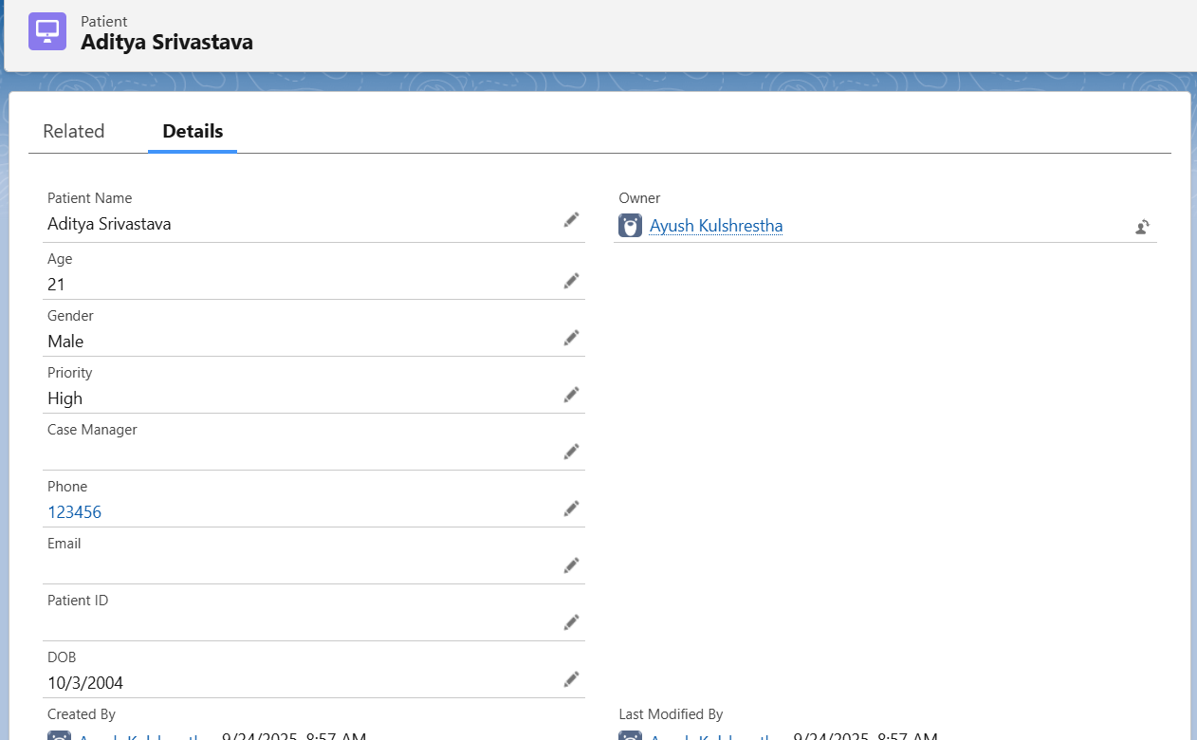

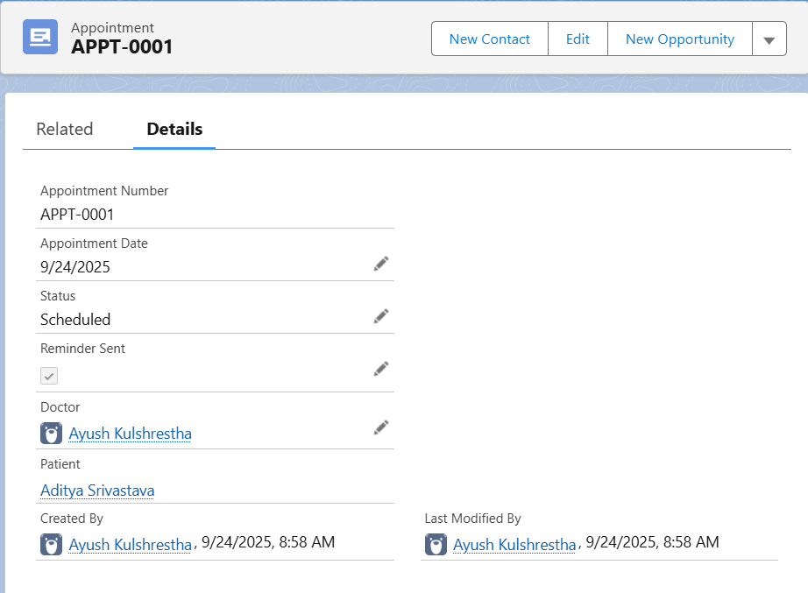

# 

# 🧾 Step 4: Related Lists Verification

Verified that related lists display correctly:

• Patient shows linked Appointments and Migrant Records.

• Appointment shows linked Migrant Records.

# 

# 🧹 Step 5: Cascade Delete Behavior

Test performed to check behavior when deleting a Patient record:

• With Lookup (current setup): Salesforce prevents deletion if related records exist. For example, deleting a Patient with Migrant Records shows an error.

• With Master-Detail: If configured, deleting the Patient will automatically delete all related Appointments and Migrant Records.

# 

# ✅ Expected Outcome

The relationships ensure robust healthcare workflows:  
• A Patient can have multiple Appointments.  
• Each Appointment can have multiple Migrant Records.  
• Patient deletion is controlled (safe with Lookup, automated with Master-Detail).  
• Healthcare officers, doctors, and staff can easily navigate between Patients, Appointments, and Migrant Records.